Exercise 1 [ANSWER]

Answer ALL the questions based on the Student SPSS file:
- Perform the frequency analysis to answer the following questions.

Gender
 |  | Frequency | Percent | Valid Percent | Cumulative Percent
Valid | Male | 14 | 56.0 | 56.0 | 56.0
Valid | Female | 11 | 44.0 | 44.0 | 100.0
Valid | Total | 25 | 100.0 | 100.0

- Percentage of males: 56%
- Percentage of females: 44%

Race
 |  | Frequency | Percent | Valid Percent | Cumulative Percent
Valid | Malay | 9 | 36.0 | 36.0 | 36.0
Valid | Chinese | 9 | 36.0 | 36.0 | 72.0
Valid | Indian | 5 | 20.0 | 20.0 | 92.0
Valid | Others | 2 | 8.0 | 8.0 | 100.0
Valid | Total | 25 | 100.0 | 100.0

- Provide the frequencies based on their race.

Malay = 9
Chinese = 9
Indian = 5
Others = 2

- Provide the cumulative percentage based on the race.

Malay = 36
Chinese = 72
Indian = 92
Others = 100

- What year has the highest intake? What is the percentage?

Intake
 |  | Frequency | Percent | Valid Percent | Cumulative Percent
Valid | 2006 | 3 | 12.0 | 12.0 | 12.0
Valid | 2007 | 6 | 24.0 | 24.0 | 36.0
Valid | 2008 | 10 | 40.0 | 40.0 | 76.0
Valid | 2009 | 6 | 24.0 | 24.0 | 100.0
Valid | Total | 25 | 100.0 | 100.0

Year with the highest intake = 2008
Percentage = 40%

- Provide the Mean, Median, Mode, Range and SD for the final marks.

Statistics
Final
N | Valid | 25
N | Missing | 0
Mean |  | 70.8400
Median |  | 75.0000
Mode |  | 72.00ª
Std. Deviation |  | 18.56673
Range |  | 70.00

Mean = 70.84
Median = 75.00
Mode = 72.00
Range = 70.00
Standard Deviation = 18.56673

- We want to know if the data are normally distributed for gender, intake and race. Draw the histogram with the normality curve to find out.

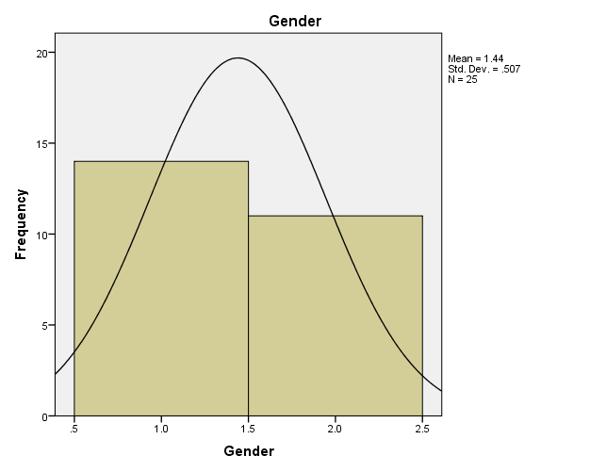

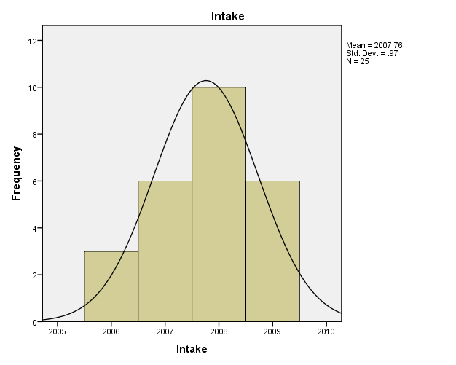

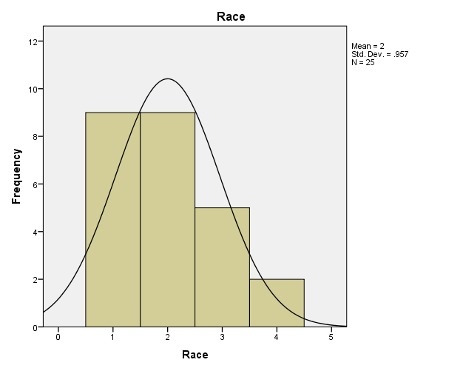

- Show the frequencies for Race using a pie chart. Which race has the highest frequency and which has the lowest?

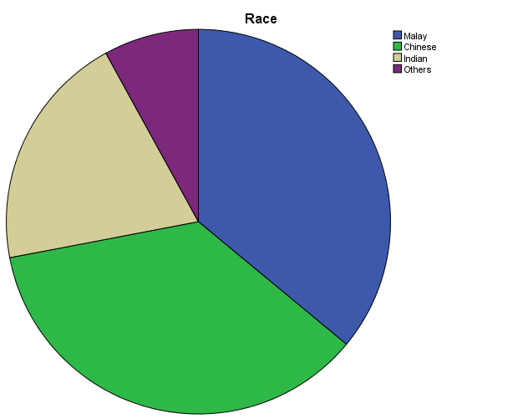

Race of highest frequency = Malay & Chinese
Race of lowest frequency = Others

- Use a cross-tab to show gender segregations and grades obtained. Include the bar chart as well.

Gender * Grade Crosstabulation
Count
 |  | Grade |  |  |  | Total
 |  | A | B | C | F | Total
Gender | Male | 8 | 5 | 1 | 0 | 14
Gender | Female | 1 | 4 | 3 | 3 | 11
Total |  | 9 | 9 | 4 | 3 | 25

